**Car Damage Assessment for Insurance Companies**

**Abstract:** Analysis of the damaged vehicle that can be automatically claiming insurance that takes human resource, time and effort. Image processing and machine learning techniques are analysing the vehicle damage in the proposed solution. In Advanced solution helps to speed up the claiming process sufficiently. Consider a situation, if a person is driving a car they met an accident the vehicle owner can taken a few photos of the damaged car from a mobile phone that can be send to the insurance company and can just upload the photos to the system. The system can analyse the damage, severity of the damage as well as location of the damage. In this proposed project the insurance company can machine-driven the car damage analysis process without the need for humans to analyse the damage done to the car. Therefore, it is a very challenging task for quality of computer vision techniques and also Machine learning technologies.

**Keywords:** Car Damage Detection, Prediction, Deep Learning, CNN, VGG16.

1. **INTRODUCTION** In today’s world, Vehicles are increasing heavily. Because of increasing the vehicles, accidents are very common because the peoples are driving a car very fastly on the road. The people claim the money for repair the car through vehicle insurance when the accident happens. Because of incorrect claims, the company behaves badly and doesn’t make payments currently. This happens due to claims leakage, the claims leakage refers to the difference between the amounts secured by the company to the amount that company should have secured based on the claims. Still the damage to the car is examined clearly and it will take more time to claim the process according to the company policy. Although the company does one’s best to speed up the claiming process delay. Differentiate the proposed system that is maybe speed up the car damage that can be check in process. Just by sending the image containing a damaged car and can system performs car damage detection in a minute rather than hours if it is inspected visually. The system can utilizes machine learning approach as well as computer vision to decide the damage analysis, location of the damage as well as severity of the damage.
2. **LITERATURE SURVEY** In this literature survey several methods have been proposed for detection of car damage. Srimal et al. [ 4 ] proposed a solution which uses 3D Computer Aided Design for the discernment of car damage from the picture, the system only detect damage at edge portion only. Detection of the car damage through CAD software requires some knowledge about the software. S Gontscharov et al [ 5 ] ,the proposed system designed by using YOLO(you only look once) algorithm to detect tha car damage, Here the multi sensor data fusion technique is allows to locate the portion of damage more accurately and performs detection faster compared to other algorithms which is fully automatic and doesn’t require much human intervention. Phyu Mar Kyu et al [ 3 ], the proposed system uses deep learning based algorithm are VGG16 and VGG19 damaged car detection in the real world. This algorithm notice the severity of the damaged car based on the location. Finally the author concludes that L2 regularization work greater. Girish N et al [ 2 ], the proposed system uses vehicle damage detection technique depends on transfer learning and mask RCNN, The mask regional convolution neural network determines a damaged car by its position and estimate the depth of the damage. A Neela Madheswari et al [ 1 ], the proposed system uses convolution neural network is use to accept that image contains a car damage or not. It take as great opportunities to attempt by classifying the car damage into different classes
3. **PROPOSED METHODOLOGY** Detect the car damage using photo taken at the accident scene is very useful to reduce the cost of processing insurance claims, as well as provide greater convenience for vehicle users. The following methods are used in the proposed system.

**1.** Dataset Explanation.

**2.** Describing the level of damage.

**3**. CNN Model.

**4.** VGG16 Algorithm.

**Dataset Explanation**

Data preparation is very costly depending on the demand of marking the data.VGG16 can be used to need as a true image in an input. Cross-validation is an approximate for our models to takes a more time since, it is very costly to train the VGG16 for many years. Consequently split the dataset arbitrarily into distinct set for training and validation. Car is to train for multiple times. At the end train and test can be split for similar images. In this dataset we use more different types of car images. Report our three collected datasets are following.

• Image Net dataset - Vehicle

• Dataset - All the three dataset are contained train and validation of damaged and undamaged cars.

**Describing the Level of Damage**

Damaged car can be defined by their incidence. We think about each damaged part into small, average, severe. The categorization of the damaged car levels as follows.

• Small Damage - creaks in headlight.

• Average Damage - Damage in car doors.

• Severe Damage - damage of air bags.

**CNN Model** CNN is one of the neural network it is used for processing the image and segmentation of the image. In this project we use a convolution neural network model for detect the image contains a car. CNN is also used to analyses the damage of the car.

**VGG16 Algorithm** The Image Net Large Scale Visual Recognition Challenge is one of the visions of computer. They contain two jobs. Initial is to detect things within an image called object localization. Next is to classifying the images called image classification. CNN is the one of the best vision model planning. In VGG16 contains four layers they are convolution, max pooling, and fully connected softmax. In this algorithm 16 refers to contain 16 layers. Impact Factor: 6.252 In this diagram they tell about the working of the project. In the first block they took a damaged car as an input. Once this image is given as an input after that they apply neural network is to be interesting for detecting the image hold the car. Car detection is done perfectly, then goes to the next step or else does not go to the next step. Detection of the car is done perfectly then analyse the damage of the car by applying the neural network. Check for car it may contains any damage then go to next step or does not proceed to the next step. If the damage is detect in the system estimate the location in the damaged car like front, back, and side of the car. They give the accurate result for the location of damaged car, and also give severity like minor, moderate, and severe. In this system they carry out some functions including car detection, car damage analysis, predict the location of the damaged car and also car damaged severity.

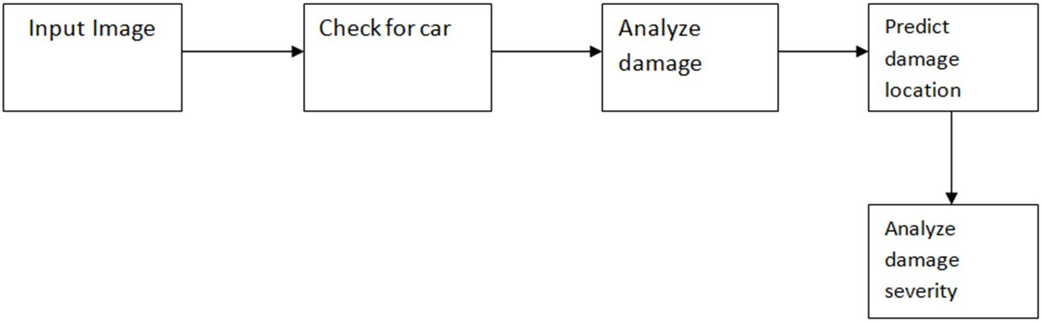

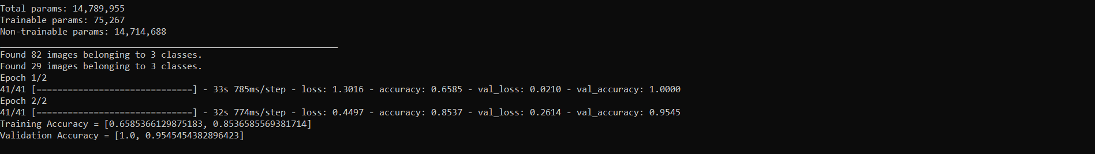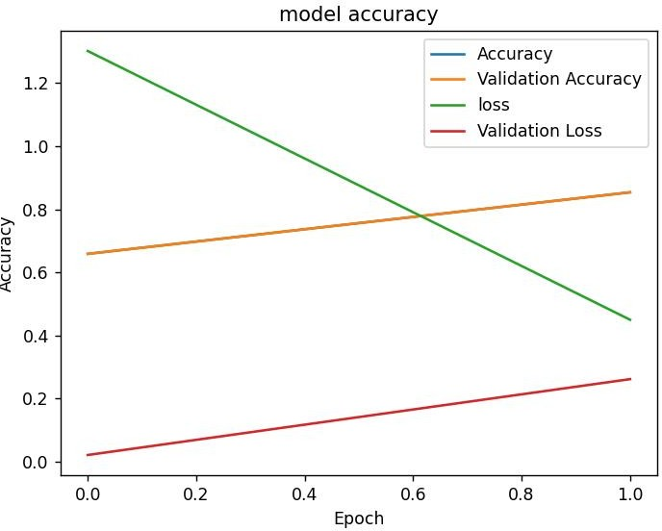**IV. EXPERIMENTAL RESULTS** First we have to train the image contains a car. The data contains three classes namely train, test and validation. Trained image is compare with the test image. Car as to be trained for many times by using epochs which means how many times the algorithm can work between the whole training dataset. In this graph they can taken only two times of running the algorithm. Finally the comparison is completed lastly print the graph containing accuracy, validation accuracy, loss and validation loss that is

